|  |  |  |
| --- | --- | --- |
| **Tech Saksham**  Final Project Report  **FULL STACK WEB DEVELOPMENT** |  |  |

**“Elder Care Management System”**

**“IIIT RGUKT RK-VALLEY”**

|  |  |
| --- | --- |
| **ROLL NO** | **NAME** |
| R170886 | Karumuru Madhavi |
| R170885 | Peddapothula Gowri Varalakshmi |

|  |  |
| --- | --- |
|  |  |
|  | Poovaragavan Velumani  Trainer Name |
|  |  |

**ABSTRACT**

An old age home is a shelter that is home to the older and needy people who the family has abandoned. Now a days homeless old age people are increasing rapidly, even though we have a lot of old age homes, many of us does not know about their address, location, strength, its activities etc. And there are many individual websites for a particular old age home, but there is no website which gives data about all the old age homes and which can handle every old age home through a single website. Our project is about the website which gives data about every old age home and we manage every old age home through a single website.

In this project, we have developed a website which can handle multiple old age homes. This website contains five major sections, those are, the admin, the vacancy check, the donation, the volunteer and the media. Admin page is for the one who take care of the old age home, this admin performs all the functions like adding old age home person data, removing person data etc. The vacancy check page is useful for users to get the data related to every old age home. Through donation section people can donate the money to the organizations. People who want to work as a volunteer can contact us through this component. And finally media section displays the all the activities performed through this website

**INDEX**

|  |  |  |
| --- | --- | --- |
| **Sr. No.** | **Table of Contents** | **Page No.** |
| 1 | Chapter 1: Introduction | 1-2 |
| 2 | Chapter 2: Services and Tools Required | 3-4 |
| 3 | Chapter 3: Project Architecture | 5 |
| 4 | Chapter 4: Architecture Blocks Detail Working | 6-8 |
| 5 | Chapter 5: Project Budget | 9 |
| 6 | Conclusion | 10 |
| 7 | References | 11 |
| 8 | Code | 12 |

**CHAPTER 1**

**INTRODUCTION**

* 1. **Overview:**

The aging of population is a global issue, most children who are busy with their work have little time to take care of their parents and have a great pressure on parent support. As most elderly become empty nesters, monitoring the living status of them is to solve not only family problems but also social problems. Even though there are multiple number of old age homes, people doesn’t know anything about those homes location, address, the capacity of particular old age home, the activities of particular old age home etc. There are some people who want to help these homeless elder people, due to lack of information about the old age home addresses or they may doesn’t know how to join these old age persons in old age homes. This is where the ELDER CARE MANAGEMENT SYSTEM enters helps in streamlining the whole process, where people can get all the data about every old age home system, people can contact with admin of old age home he/she wants. There is an individual admin for every old age home. He provides information about the process and he clarifies people queries. Each old age home system has separate id called admin id. Admin manages the old age home data based on this admin id.

People can get all the data about particular old age home through vacancy check section. This component provides old age home address, admin mobile number, id of the old age home etc. Through donation section people can donate fund for the organization, donated people data stores in database once they complete their payment. People can work as volunteers by enroling their details in the form given in volunteer section. People can get all the information about the activities and functions of home through about us section. The security of data is done by the encrypted format and server database of the old age home**.**

* 1. **Advantages:**

• Saves user time.

• Multiple old age homes can be handled through a single website.

• Users can check vacancies of every old age home.

• Increases users satisfaction.

• Old age home can be handled in an efficient way.

• User can choose the perfect old age home according to his/her needs

* 1. **Scope:**

The system will maintain location wise old age home details of particular region. The system will also provides the rating given the people for that old age home based on the rating people can select old age home. The system will provide list of old age homes to choose the perfect one.

* 1. **Future Work:**

The main purpose of Elder Care Management System provides all the data about multiple old age homes and multiple old age homes can be managed through this single website. This system helps admin to manage data of old aged persons in an efficient way. This system reduces the saves people time by providing every home data at one website otherwise people has to spend a lot of time for choosing the old age home.

**CHAPTER 2**

**SERVICES AND TOOLS REQUIRED**

**2.1 Requirement and specifications:**

**Client side:**

Ram - 512 MB

Hard disk - 10 GB

Processor - 1.0 GHz

**2.2 software Configuration:**

Front End - HTML, CSS, Java Script, Jquery , Mysql , PHP.

Web Browser - Firefox , Google Chrome or any compatible browser

Operating System - Ubuntu, Windows or any equivalent OS

Technology - Web Development

**2.2.1 HTML :**  HTML is the standard markup language for documents designed to be displayed in a web browser.

**2.2.2 CSS :**  Cascading Style Sheets is a style sheet language used for describing the presentation of a document written in a markup language such as HTML or XML.

**2.2.3 JavaScript :** JavaScript is a scripting language that enables you to create dynamically updating content, control multimedia, animate images, and pretty much everything else.

**2.2.4 Jquery :** jQuery is a JavaScript framework designed to simplify HTML DOM tree traversal and manipulation, as well as event handling, CSS animation, and Ajax. It is free and open source framework.

**2.2.5 My SQl :** MySQL is a widely used relational database management system (RDBMS). MySQL is free open source. This tutorial will give you great understanding on Mysql concepts needed to create and deploy a highly scalable and performance-oriented database.

**2.2.6 PHP:** PHP is mainly focused on server-side scripting, so you can do anything any other CGI program can do, such as collect from data, generate dynamic page content, or send and receive cookies. But PHP can do more.

**CHAPTER 3**

**PROJECT ARCHITECTURE**

**3.1 Architecture**

**USER FRONTEND BACKEND**

|  |  |  |
| --- | --- | --- |
|  | **HTML 5** | **NODEJS 14.0**  **Database** |

**CHAPTER 4**

**ARCHITECTURE BLOCKS DETAIL WORKING**

**4.1 Blocks**

**Use case Diagram:**

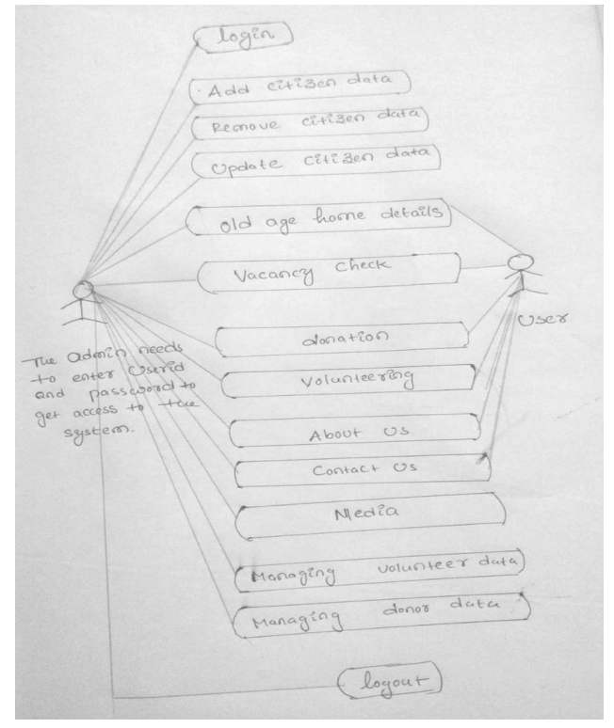

A Use case is a description of set of sequence of actions. Graphically it is rendered as an ellipse with solid line including only its name. Use case diagram is a behavioural diagram that shows a set of use cases and actors and their relationship. It is an association between the use cases and actors. An actor represents a real-world object. Primary Actor – Sender, Secondary Actor Receiver.

**Sequence Diagram:**

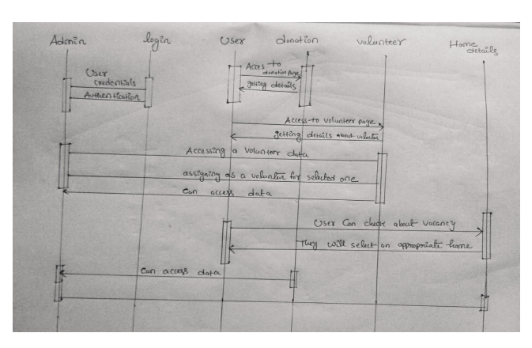

**ER Diagram:**

The Entity-Relationship (ER) model was originally proposed by Peter in 1976 [Chen76] as a way to unify the network and relational database views. Simply stated the ER model is a conceptual data model that views the real world as entities and relationships. A basic component of the model is the Entity-Relationship diagram which is used to visually represent data objects. Since Chen wrote his paper the model has been extended and today it is commonly used for database design for the database designer, the utility of the ER model is: • It maps well to the relational model. The constructs used in the ER model can easily be transformed into relational tables. • It is simple and easy to understand with a minimum of training. Therefore, the model can be used by the database designer to communicate the design to the end user. • In addition, the model can be used as a design plan by the database developer to implement a data model in specific database management software.

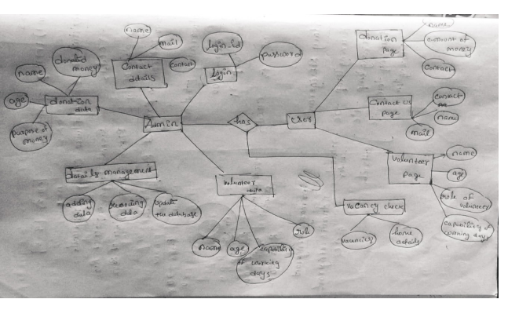

**CHAPTER 5**

**PROJECT BUDGET**

**This project is build by taking reference from different websites and with the help of trainer. No external resourced were bought to complete the project**

**CONCLUSION**

The development of Elder Care Management System involved many phases. We have used the top-down approach, in this approach, first we concentrate on first level and moving to successive levels. The first phase started with a detailed study of the problems. This system is efficient in maintaining old age home details, multiple old age homes can be maintained through single software. It provides all the old age homes data at one place and saves users time.

**REFERENCES**

For HTML : https://www.w3schools.com/html/html_intro.asp https://www.geeksforgeeks.org/html/

For CSS : https://www.w3schools.com/css/css_intro.asp <https://www.tutorialspoint.com/css/index.html>

For Javascript: https://www.w3schools.com/js/js_intro.asp https:/ /www.javatpoint.com/javascript-tutorial

For Jquery: h ttps://www.tutorialspoint.com/jquery/index.htm l <https://www.w3schools.com/jquery/>

For PHP: https://www.javatpoint.com/php-tutorial h ttps://www.geeksforgeeks.org/php-tutorials/

For Mysql: https://www.w3schools.com/MySQL/default.asp

**CODE**

https://github.com/kmadhavi4566/Project-1